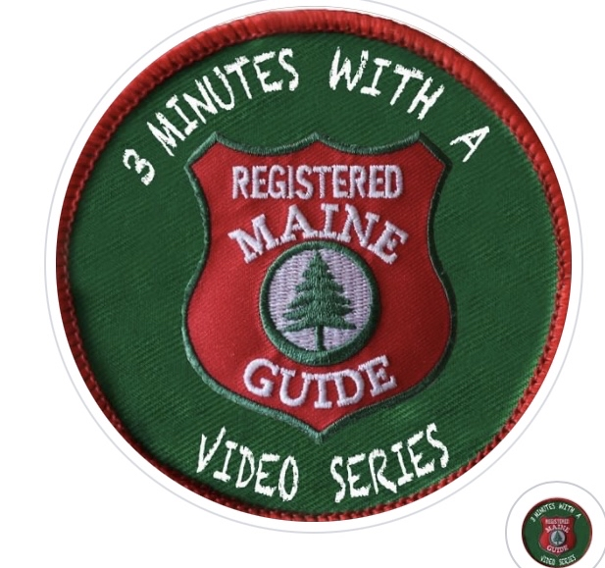

Page 1 of 3

**Policy:**

**3 Minutes with a Maine Guide in conformance with our liability insurance coverage, as well as accepted safety standards of the profession, requires that all participants wear personal flotation devices (PFD) at all times on the water. 3 Minutes with a Maine Guide also prohibits the use of alcohol, cannabis or CBD products while participating in on land or on water workshops.**

**Signing below acknowledges these specific company policies and participants agree to abide by them. Participants also agree to carry out what you carry in and minimize your impact on the environment.**

**Release and acknowledgment of risk**

**In consideration of the services of 3 Minutes with a Maine Guide, their agents, owners, volunteers, participants, employees and all other persons or entities acting in any capacity on their behalf here in collectively referred to as (3 Minutes) I hereby agree to release and discharge 3 Minutes, on behalf of myself, my children, my heirs, personal representative and estate as follows:**

**I acknowledge that boating, hiking, open fires, etc, entails known and unanticipated risks which could result in physical or emotional injury, paralysis, death, or damage to myself, to property, or third parties. I understand that such risks simply cannot be eliminated without jeopardizing the essential quality of the activity. I will be camping and canoeing in the areas that are geographically remote and / or physically difficult to reach. This means in case of accident or injury it may be difficult or impossible to rescue me or to promptly get me professional medical attention. The risks include, among other things:**



**Page 2 of 3**

**Traveling down rivers and lakes in open Canoes. Hiking, climbing or otherwise negotiating mountainous and or forested terrain. Accidents or illness in remote places without medical facilities, forces of nature and travel by truck, Auto or other conveyance. You can be jolted, bounced, thrown too and fro and shaken about during Rapids. It is possible that you could be injured if you come in contact with food boxes, other storage containers, or fixed equipment necessary to the operation of the expedition and outfitting of the boats. Boats could turn over on you or you could be washed overboard. You can slip or fall during a hike, resulting in damage to equipment or personal injury. Exposure to the elements can be uncomfortable and or harmful. You should be aware that this exposure could cause sunburn, dehydration, heat exhaustion, heat stroke, and heat cramps. Also prolong exposure to cold water can result in hypothermia and in extreme cases death. Accidental drowning is also a possibility. You will be traveling and camping in an area that is inhabited by biting and or stinging insects, bears and other wildlife. Contact with wildlife involves certain risks that are beyond the control of the Guides. 3 Minutes Guides have a difficult job to perform. They seek safety, but they are not infallible. They might be Unaware of a participants fitness or abilities. They might misjudge the weather, the elements, or the terrain. They might give inadequate warnings or instructions, and the equipment being used might malfunction. There will be other guests on this trip who by their own carelessness, clumsiness or other actions (intentional or unintentional) may injure me.**

* **I expressly agree and promise to accept and assume all of the risk existing in this activity. My participation in this activity is purely voluntary, and I elect to participate in spite of the risk.**
* **I hereby voluntarily release, forever discharge, and agree to indemnify and hold harmless 3 Minutes from any and all claims, demands, or causes of action, which are in any way connected with my participation in this activity, or my use of 3 Minutes equipment or facilities, including any such claims which allege negligent acts or omissions of 3 Minutes.**



**Page 3 of 3**

* **Should 3 Minutes or anyone acting on their behalf, be required to incur attorneys fees and cost to enforce this agreement, I agree to indemnify and hold them harmless for all such fees and costs.**
* **I certify that I have adequate insurance to cover any Injuries or damage I may occur or suffer while participating, or else I agree to bear the cost of any injury or damage to myself. I further certify that I have no medical or physical condition which could interfere with my safety in this activity, or else I am willing to assume and bear the cost of all risks that may be created, directly or indirectly, by any such condition.**

**By signing this document I acknowledge that if anyone is hurt or property damaged during my participation in this activity, I may be found by a court of law to have waived my right to maintain a lawsuit against 3 Minutes on the basis of any claim from which I have released them herein. I have had sufficient opportunity to read this document I have read and understood it, and I agree to be bound by its terms.**

**Signature of Participant:____________________ Date: ____________**

**Print Name: ___________________**

**Parent or guardian’s additional information**

**In consideration of_____________________ (Print minor’s name) Being permitted by 3 Minutes Guides to participate in its activities and to use equipment, I further agree to indemnify and hold harmless 3 Minutes from any and all claims which are brought by, and on behalf of minor, and which are in anyway connected with such use or participation by minor.**

**Signature _____________________ Date: ____________**

**Print Name: ____________________**